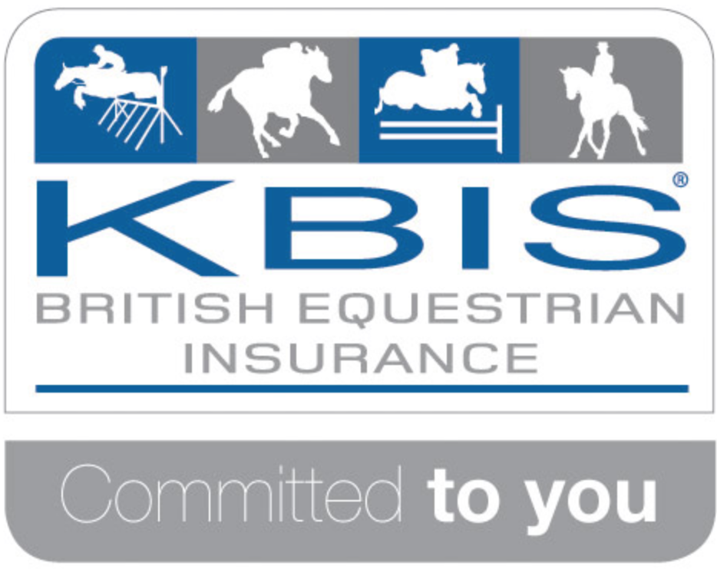
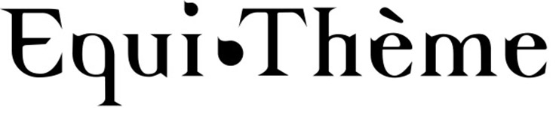

SEVERN VALE RIDING CLUB

www.severnvalerc.org.uk

Area 9 BRC Junior Winter Dressage
(KBIS Novice and Equitheme Intermediate Dressage, Team and Individual)

Sunday 4th December 2016

Leyland Court Farm

Trench Lane, Winterbourne, Bristol BS361RY

By kind permission of Leyland Court Equestrian Centre
Paramedics in attendance
Refreshments – Castle Catering

Class 1: Junior Novice. 2 team members ride Prelim 2 (2016), 2 team members ride Novice 27(2007). Individuals may enter, but no horse may be ridden twice in the same test. (All team members are automatically part of the individual competition)
Class 2: Junior Intermediate. Each team member rides one of prelim 7 (2002), Novice 30 (2006), Novice 34(2009), Elementary 43(2006). Individuals may enter, but no horse may be ridden twice in the same test. (All team members are automatically part of the individual competition)
Riders and horses may compete in both class 1 and class 2 provided they meet the eligibility criteria – see BRC rule book).
Where riders are riding more than one test, we cannot guarantee the lower level one will be first, though every effort will be made to accommodate this.

Entry fee: Team £60 Individual £15
Cheques payable to Severn Vale Riding Club.
BACS payments: Lloyds, 30 98 29 04108565
Prelim entries (to BRC) close: 11th November 2016
(Prelim entry form can be downloaded from BRC website, or pay on line via BHS bookshop)
Area entries close: Wednesday 23rd November 2016
(Entries on BRC Area Entry Form, available as Download from BRC website)

Vaccination Records: Please email new or updated vaccination records and passport numbers in good time to area9vaccinations@outlook.com

Entries Secretary: Alison Brown, 83 The Meadows, Hanham, Bristol BS15 3PB Mob: 07950 027477 email: please send to shelaghfishlock@gmail.com

Times will be available on the A9 website and on www.severnvalerc.org.uk from Thursday 1st December 2016

Rules

- The competition will be run strictly under British Riding Club rules 2016.
- ALL HORSES/PONIES ENTERED FOR BRC QUALIFIERS MUST HAVE A VACCINATION RECORD COMPLYING WITH BRC RULES, WHICH MUST BE BROUGHT ON THE DAY OF THE COMPETITION. IT IS THE RESPONSIBILITY OF THE CHEF D’EQUIPE TO ENSURE THESE ARE CORRECT. ANY INCORRECT CERTIFICATES WILL RESULT IN THAT TEAM MEMBER’S DISQUALIFICATION.
- Chefs d’equipe should check the full BRC eligibility criteria for all horses and riders.
- Declarations should be presented to the Secretary prior to the start of the Class. Alternatively they may be emailed to the Area rep shelaghfishlock@gmail.com up to 8pm on the previous evening. Only simple changes to teams will be permitted once times have been posted (ie horse/rider replacing existing position in a team),
- Entries will not be accepted without the correct entry fees. Cheques should be made payable to Severn Vale Riding Club. Teams should send a single Riding Club cheque to accompany the Area Entry Form. BACS payments: Lloyds, 30 98 29 04108565
- In the event of withdrawals, the organisers regret that they cannot refund entry fees after the close of entries.
- Hats up to current standards with 3 point restraining harness MUST be worn and fastened at all times when mounted. All hats must have a BRC orange tag PRIOR TO RIDING in BRC qualifiers.
- BRC health and safety guidelines apply at all times
- Neither SVRC, BRC Area 9 or Leyland Court EC will hold themselves responsible for any accident to persons, property and/or horses attending this show
- The judges decision is FINAL
- ONLY persons and/or horses competing may use the warm up facilities at Leyland Court
- Competitors are requested not to leave litter or muck out horse boxes in the box park
- Horses must not be tied to horseboxes or trailers and left unattended
- All ridden horses/ponies must be 4 yrs or over
- Objections to be made to the Secretary in writing within 10 minutes of the end of the class and accompanied by a £10 deposit
- All persons attending the show will be deemed to have accepted the rules and conditions.

